Photosynthesis

Photosynthesis is the way green plants make there own food. It is the production of organic compounds from inorganic molecules using light energy trapped by chlorophyll.
Energy from the sun is used to combine hydrogen from water with carbon dioxide from the air into carbohydrates such as glucose. The glucose produced can be used in respiration, stored as starch, converted to lipids or used to form proteins by adding elements such as nitrogen. Photosynthesis is an anabolic reaction and is a long series of enzyme controlled steps but can be summarised as follows
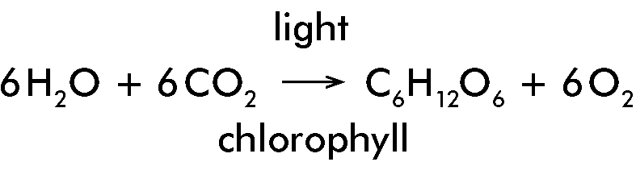

Summary
Light energy is absorbed by chlorophyll. The absorbed light energy is used to make ATP. Light energy is used for the photolysis or splitting of water. The photolysis of water releases H₂. Glucose is produced by the 'reduction' of CO₂ by combining it with H₂. ATP supplies the energy for this. O₂ is a by-product of water splitting.

Light Stage.
The light stage reactions occur only in the grana and in the presence of light. Chlorophyll in chloroplasts traps sunlight energy. High-energy electrons are released from chlorophyll. These electrons then follow one of two pathways.

Pathway 1
The electrons are passed along a series of carriers and release energy to form ATP and are eventually returned to chlorophyll.

Pathway 2
Water is split into H⁺ and OH⁻. Free electrons (from chlorophyll) are used to give NADP a negative charge which then can attach to H⁺ to form NADPH₂. OH⁻ releases its electrons along a carrier system back to chlorophyll and then decomposes to form O₂ and H₂O.

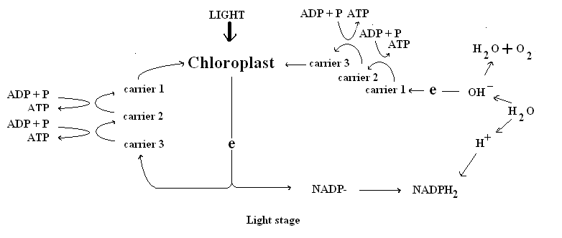

Dark Stage.
Dark stage reactions occur in both light and dark and occur in the stroma of the chloroplast. ATP formed in the light stage is used to combine Hydrogen from NADPH₂ with trapped carbon doxide to form glucose. NADP, ADP and P are reformed and returned to the grana.

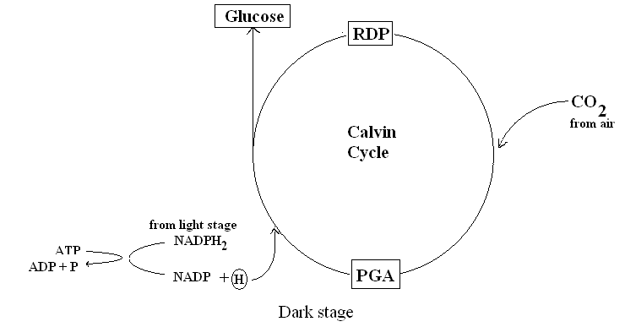
Factors which affect photosynthesis
The rate of photosynthesis increases as light intensity or carbon dioxide levels increases. If any factor such as carbon dioxide, light or temperature becomes in short supply then it is called a limiting factor and prevents any further increase in the rate of photosynthesis. A plant is light saturated when an increase in light intensity does not increase the rate of photosynthesis.
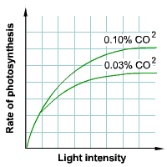

Promoting Crop Growth in Greenhouses
Artificial Lighting
Increase the light intensity to increase the rate of photosynthesis and increase the light duration to increase the total amount of photosynthesis.
Increase Carbon Dioxide Concentration:
Raises the rate of photosynthesis so more food produced. Carbon dioxide enrichment is achieved by gas cylinders or kerosene burners.

